bLUE dART DATA ANALYSIS

**Over – Viewing the Data**

SELECT * FROM Order_Details

SELECT * FROM Orders

SELECT * FROM Products

SELECT * FROM Shippers

SELECT * FROM Suppliers

SELECT * FROM Categories

SELECT * FROM Employee_Details

**KPI’s Analysis**

1. **Total Revenue**

SELECT FORMAT(SUM(OD.QUANTITY * P.PRICE),'C','EN-US') AS TOTAL_REVENUE

FROM Order_Details AS OD JOIN Products AS P ON OD.ProductID = P.ProductID

**Output:**



1. **Total Orders**

SELECT COUNT(ORDERID) AS TOTAL_ORDER FROM Order_Details

**Output:**



1. **Total Quantity**

SELECT SUM(Quantity) AS TOTAL_QUANTITY FROM Order_Details

**Output:**



1. **Showcasing Employee Name, Employee ID, Qualification by their Age**

SELECT Name, EmployeeID, Age, Qualification FROM Employee_Details ORDER BY AGE DESC

**Output:**

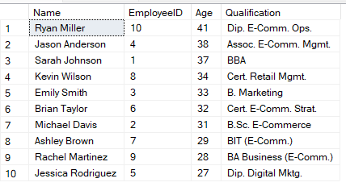

1. **Showcasing Shippers Name, Rate, Carrier Type, Service Coverage**

SELECT ShippersName, ShippersID, [Carrier Type], [Rates ], [Service Coverage] FROM Shippers

**Output:**

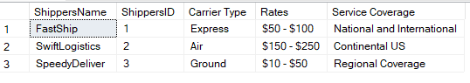

1. **Viewing Shippers Count by Country**

SELECT Country, COUNT(SUPPLIERID) AS TOTAL_SUPPLIERS FROM Suppliers GROUP BY Country

**Output:**

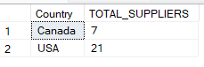

1. **Revenue by Each Year**

SELECT DATEPART(YEAR,O.OrderDate) AS YEAR,

FORMAT(SUM(OD.QUANTITY * P.PRICE),'C','EN-US') AS TOTAL_REVENUE

FROM Order_Details AS OD JOIN Orders AS O ON OD.OrderID = O.OrderID

JOIN Products AS P ON OD.ProductID = P.ProductID

GROUP BY DATEPART(YEAR, O.OrderDate)

ORDER BY YEAR

**Output:**

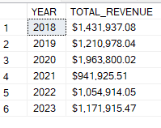

1. **Revenue by Each Quarter**

SELECT SQ.YEAR,

FORMAT(SUM(CASE WHEN SQ.YEAR_QUARTER = 1 THEN SQ.TOTAL_REVENUE ELSE 0 END),'C','EN-US') AS Q1_REVENUE,

FORMAT(SUM(CASE WHEN SQ.YEAR_QUARTER = 2 THEN SQ.TOTAL_REVENUE ELSE 0 END),'C','EN-US') AS Q2_REVENUE,

FORMAT(SUM(CASE WHEN SQ.YEAR_QUARTER = 3 THEN SQ.TOTAL_REVENUE ELSE 0 END),'C','EN-US') AS Q3_REVENUE,

FORMAT(SUM(CASE WHEN SQ.YEAR_QUARTER = 4 THEN SQ.TOTAL_REVENUE ELSE 0 END),'C','EN-US') AS Q4_REVENUE

FROM(SELECT DATEPART(YEAR,O.OrderDate) AS YEAR, DATEPART(QUARTER, O.ORDERDATE) AS YEAR_QUARTER,

SUM(OD.QUANTITY * P.PRICE) AS TOTAL_REVENUE

FROM Order_Details AS OD JOIN Orders AS O ON OD.OrderID = O.OrderID

JOIN Products AS P ON OD.ProductID = P.ProductID

GROUP BY DATEPART(YEAR, O.OrderDate), DATEPART(QUARTER, O.OrderDate)) AS SQ

GROUP BY SQ.YEAR

ORDER BY SQ.YEAR

**Output:**

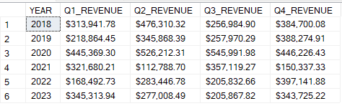

1. **Top 5 Products Sold by Quantity**

SELECT TOP 5 OD.ProductID, P.ProductName, SUM(OD.QUANTITY) AS TOTAL_QUANTITY

FROM Order_Details AS OD JOIN Products AS P ON OD.ProductID = P.ProductID

GROUP BY OD.ProductID, P.ProductName

ORDER BY TOTAL_QUANTITY DESC

**Output:**

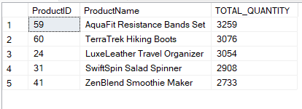

1. **Bottom 5 Product Sold by Quantity**

SELECT TOP 5 OD.ProductID, P.ProductName, SUM(OD.QUANTITY) AS TOTAL_QUANTITY

FROM Order_Details AS OD JOIN Products AS P ON OD.ProductID = P.ProductID

GROUP BY OD.ProductID, P.ProductName

ORDER BY TOTAL_QUANTITY

**Output:**

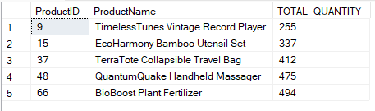

1. **5 High Revenue Generated Products**

SELECT TOP 5 OD.ProductID, P.ProductName, FORMAT(SUM(OD.QUANTITY * P.PRICE),'C','EN-US')

AS TOTAL_REVENUE FROM Order_Details AS OD

JOIN Products AS P ON OD.ProductID = P.ProductID

GROUP BY OD.ProductID, P.ProductName

ORDER BY SUM(OD.QUANTITY * P.PRICE) DESC

**Output:**

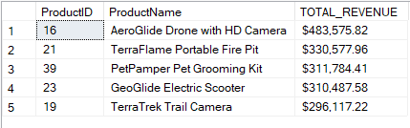

1. **5 Low Revenue Generated Products**

SELECT TOP 5 OD.ProductID, P.ProductName, FORMAT(SUM(OD.QUANTITY * P.PRICE),'C','EN-US')

AS TOTAL_REVENUE FROM Order_Details AS OD

JOIN Products AS P ON OD.ProductID = P.ProductID

GROUP BY OD.ProductID, P.ProductName

ORDER BY SUM(OD.QUANTITY * P.PRICE)

**Output:**

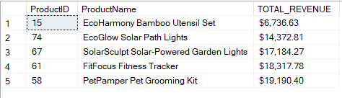

1. **5 Most Ordered Products**

SELECT TOP 5 OD.ProductID, P.ProductName, COUNT(OD.ORDERID) AS TOTAL_ORDERS

FROM Order_Details AS OD JOIN Products AS P ON OD.ProductID = P.ProductID

GROUP BY OD.ProductID, P.ProductName

ORDER BY TOTAL_ORDERS DESC

**Output:**

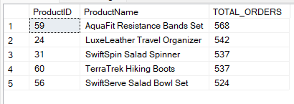

1. **5 Least Ordered Products**

SELECT TOP 5 OD.ProductID, P.ProductName, COUNT(OD.ORDERID) AS TOTAL_ORDERS

FROM Order_Details AS OD JOIN Products AS P ON OD.ProductID = P.ProductID

GROUP BY OD.ProductID, P.ProductName

ORDER BY TOTAL_ORDERS

**Output:**

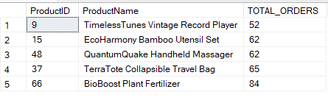

1. **Sales By Category**

SELECT P.CategoryID, C.CategoryName, COUNT(OD.ORDERID) AS TOTAL_ORDERS,

FORMAT(SUM(OD.QUANTITY * P.PRICE),'C','EN-US') AS TOTAL_REVENUE

FROM Order_Details AS OD JOIN Products AS P ON OD.ProductID = P.ProductID

JOIN Categories AS C ON P.CategoryID = C.CategoryID

GROUP BY P.CategoryID, C.CategoryName

ORDER BY TOTAL_ORDERS DESC

**Output:**

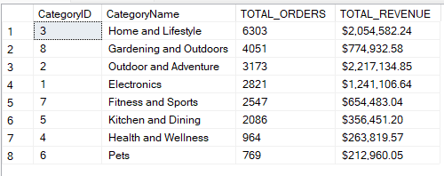

1. **Most Used Payment Method**

SELECT O.[Payment Mode], COUNT(O.[Payment Mode]) AS NO_OF_PAYMENTS

FROM Order_Details AS OD JOIN Orders AS O ON OD.OrderID = O.OrderID

GROUP BY O.[Payment Mode]

ORDER BY NO_OF_PAYMENTS DESC

**Output:**

